GTHBY DEBATE TASK
You will choose one of the following statements to debate:
- Sweden’s response is a good balance between health outcomes and the economy
- The consequences of lockdown for the human population overall will be worse than the loss of lives
- The government should be allowed to use our mobile phone location data to control the spread of disease
Each of these topics will have 6 people debating: 3 affirmative (agreeing with the statement) and 3 negative (disagreeing with the statement).
Each person will speak for 3 minutes. The recommended time for rebuttal is 1 minute (included in the 3 minutes). The debate will happen in the following format:
Affirmative Negative

Throughout this debate you are expected to address ethical concerns in a sensitive manner. Also, rebuttals must be respectful to the opposing team/speaker. Although you are disagreeing, you must do so in a polite manner.
Refer to the following rubric to see what criteria you should be working towards.

Rubric: Team Criteria
Criteria | 1-2 marks | 3-4 marks | 5 marks
Introduction to the topic | Standpoint is clear, yet definitions are missing or incorrect/irrelevant to context of argument. | The standpoint is made clear, definitions are presented, but their context in the argument is not clear. | A clear standpoint on the issue is made. Definitions are presented and explained well, within the context of the argument.
Arguments | Arguments are mostly in a logical order but some stray from main point. 1 argument per speaker. | Order of arguments is logical but some points may not be relevant. 1-2 arguments made per speaker | Order of arguments is logical and all points are relevant. 2 arguments made per speaker
Evidence  (statistics, testimony, etc.) | Most arguments have evidence but may not be valid and/or not presented well. | Most arguments are backed up by evidence, and an attempt has been made to use visual aids. | Each argument is backed up by evidence. The use of visual aids/ infographics enhances the impact.
Teamwork | Students have chosen their arguments as a group but have worked individually to construct them. Arguments may seem isolated as students do not refer to other team members’ arguments. | Students have worked together to formulate arguments, but workload may not be evenly distributed. Some reference is made to other team members’ arguments. | Students have worked together to formulate arguments and divided workload evenly. During the debate, team members refer to each other’s arguments to support their own.
Organisation | Speaker finishes within +/- 30 seconds of their allocated time. Student may be noticeably reading straight from palm cards. | Speaker finishes within +/- 20 seconds of their allocated time. Palm cards may be distracting and interrupt the flow if the argument. | Speaker finishes within +/- 10 seconds of their allocated time. Palm cards are not intrusive.
Speech | Student attempts to project and be convincing but may not be consistent. | Pace and volume is appropriate but may lack conviction. | Tone is persuasive and convincing. Speech is at a reasonable pace and volume is appropriate.

Use this chart to brainstorm ideas for your group’s argument:
Idea | Analysis | Evidence

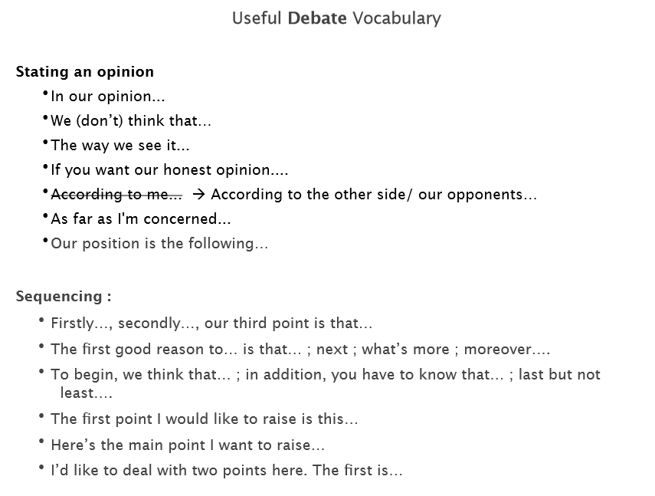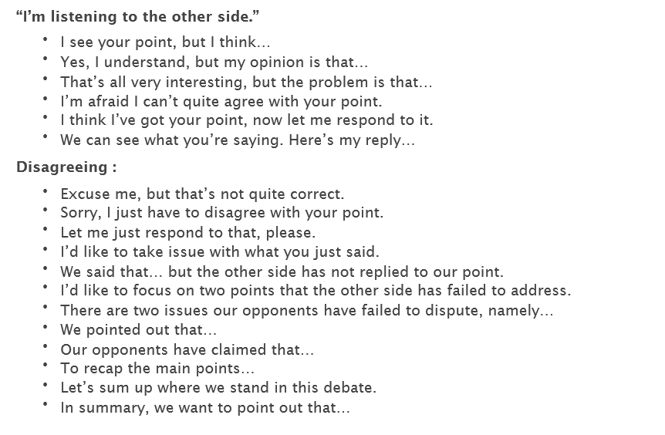
Affirmative | Negative
Persuasiveness:   | Persuasiveness:  
Clarity:   | Clarity:  
Evidence:   | Evidence:  
Feedback: | Feedback:
You will complete this self-reflection exit ticket at the end of your research session to track your progress and how you feel about your preparation.
I feel anxious about speaking in the debate
Not at all 1 2 3 4 5 6 7 A lot
I am satisfied with the amount of preparation I have done
Not at all 1 2 3 4 5 6 7 A lot
My team worked well together to choose arguments and evidence
Not at all 1 2 3 4 5 6 7 A lot
I have thought about things in a different way to guess what the other team might argue
Not at all 1 2 3 4 5 6 7 A lot

You will complete one of these Peer Feedback forms for each of the 4 debates.

Topic of the debate:

Scaffolding for literacy support:
Here are some phrases which you may wish to use to present your arguments.
(from http://crl.u-paris2.fr/polelangues/documents/ang/Eco/L2-DebateVocab.pdf )

